|  |  |  |
| --- | --- | --- |
| **®**  **WEBENCH Design Report** | VinMin = 11.0V  VinMax = 13.0V  Vout = 5.0V  Iout = 3.0A | Device = LM2596SX-5.0/NOPB  Topology = Buck  Created = 2023-10-02 12:42:56.053  BOM Cost = $4.30  BOM Count = 6  Total Pd = 3.08W |

Design : 2 LM2596SX-5.0/NOPB

LM2596SX-5.0/NOPB 11V-13V to 5.00V @ 3A

Cin

µF

120.0

mOhm

25.0

Cout

330.0

µF

mOhm

90.0

D1

VF@Io= 450.0 mV

VRRM= 40.0 V

L1

33.0

µH

33.0

mOhm

**LM2596**

Vin

FB

SW

GND

ON/OFF

U1

Vout = 5.0V

Iout = 3.0A

Vin

Iout

# Electrical BOM

Name

Manufacturer

Part Number

Properties

Qty

Price

Footprint

Cf

Samsung Electro-

Mechanics

[CL21C332JBFNNN](http://www.samsungsem.com/servlet/FileDownload?type%3Dspec%26file%3DCL21C332JBFNNNE.pdf)

[E](http://www.samsungsem.com/servlet/FileDownload?type%3Dspec%26file%3DCL21C332JBFNNNE.pdf)

Series= C0G/NP0

Cap= 3.3 nF

VDC= 50.0 V

IRMS= 0.0 A

1

$0.04

mm

0805 7

2

Cin

Panasonic

20

SVPF120M

Series= SVPF

Cap= 120.0 uF

ESR= 25.0 mOhm

VDC= 20.0 V

IRMS= 3.2 A

1

$0.57

CAPSMT_62_F61 74 mm

2

Cout

Nichicon

[S](http://products.nichicon.co.jp/en/pdf/XJA043/e%2Dud.pdf)

[UUD1V331MNL1G](http://products.nichicon.co.jp/en/pdf/XJA043/e%2Dud.pdf)

Series= uD

Cap= 330.0 uF

ESR= 90.0 mOhm

VDC= 35.0 V

IRMS= 670.0 mA

1

$0.33

SM_RADIAL_10BMM 160 mm2

D1 Diodes Inc. [B340LA-13-F](http://www.diodes.com/datasheets/ds30240.pdf) VF@Io= 450.0 mV 1 $0.15

SMA 37 mm

2

VRRM= 40.0 V

L1 Coilcraft [MSS1210-333MEB](http://www.coilcraft.com/pdfs/mss1210.pdf) L= 33.0 µH 1 $0.81

33.0 mOhm

MSS1210 204 mm2

Name

Manufacturer

Part Number

Properties

Qty

Price

Footprint

U1

Texas Instruments

[LM2596SX-5.0/NOP](http://www.ti.com/product/LM2596)

[B](http://www.ti.com/product/LM2596)

Switcher

1

$2.40

TS5B 199 mm

2

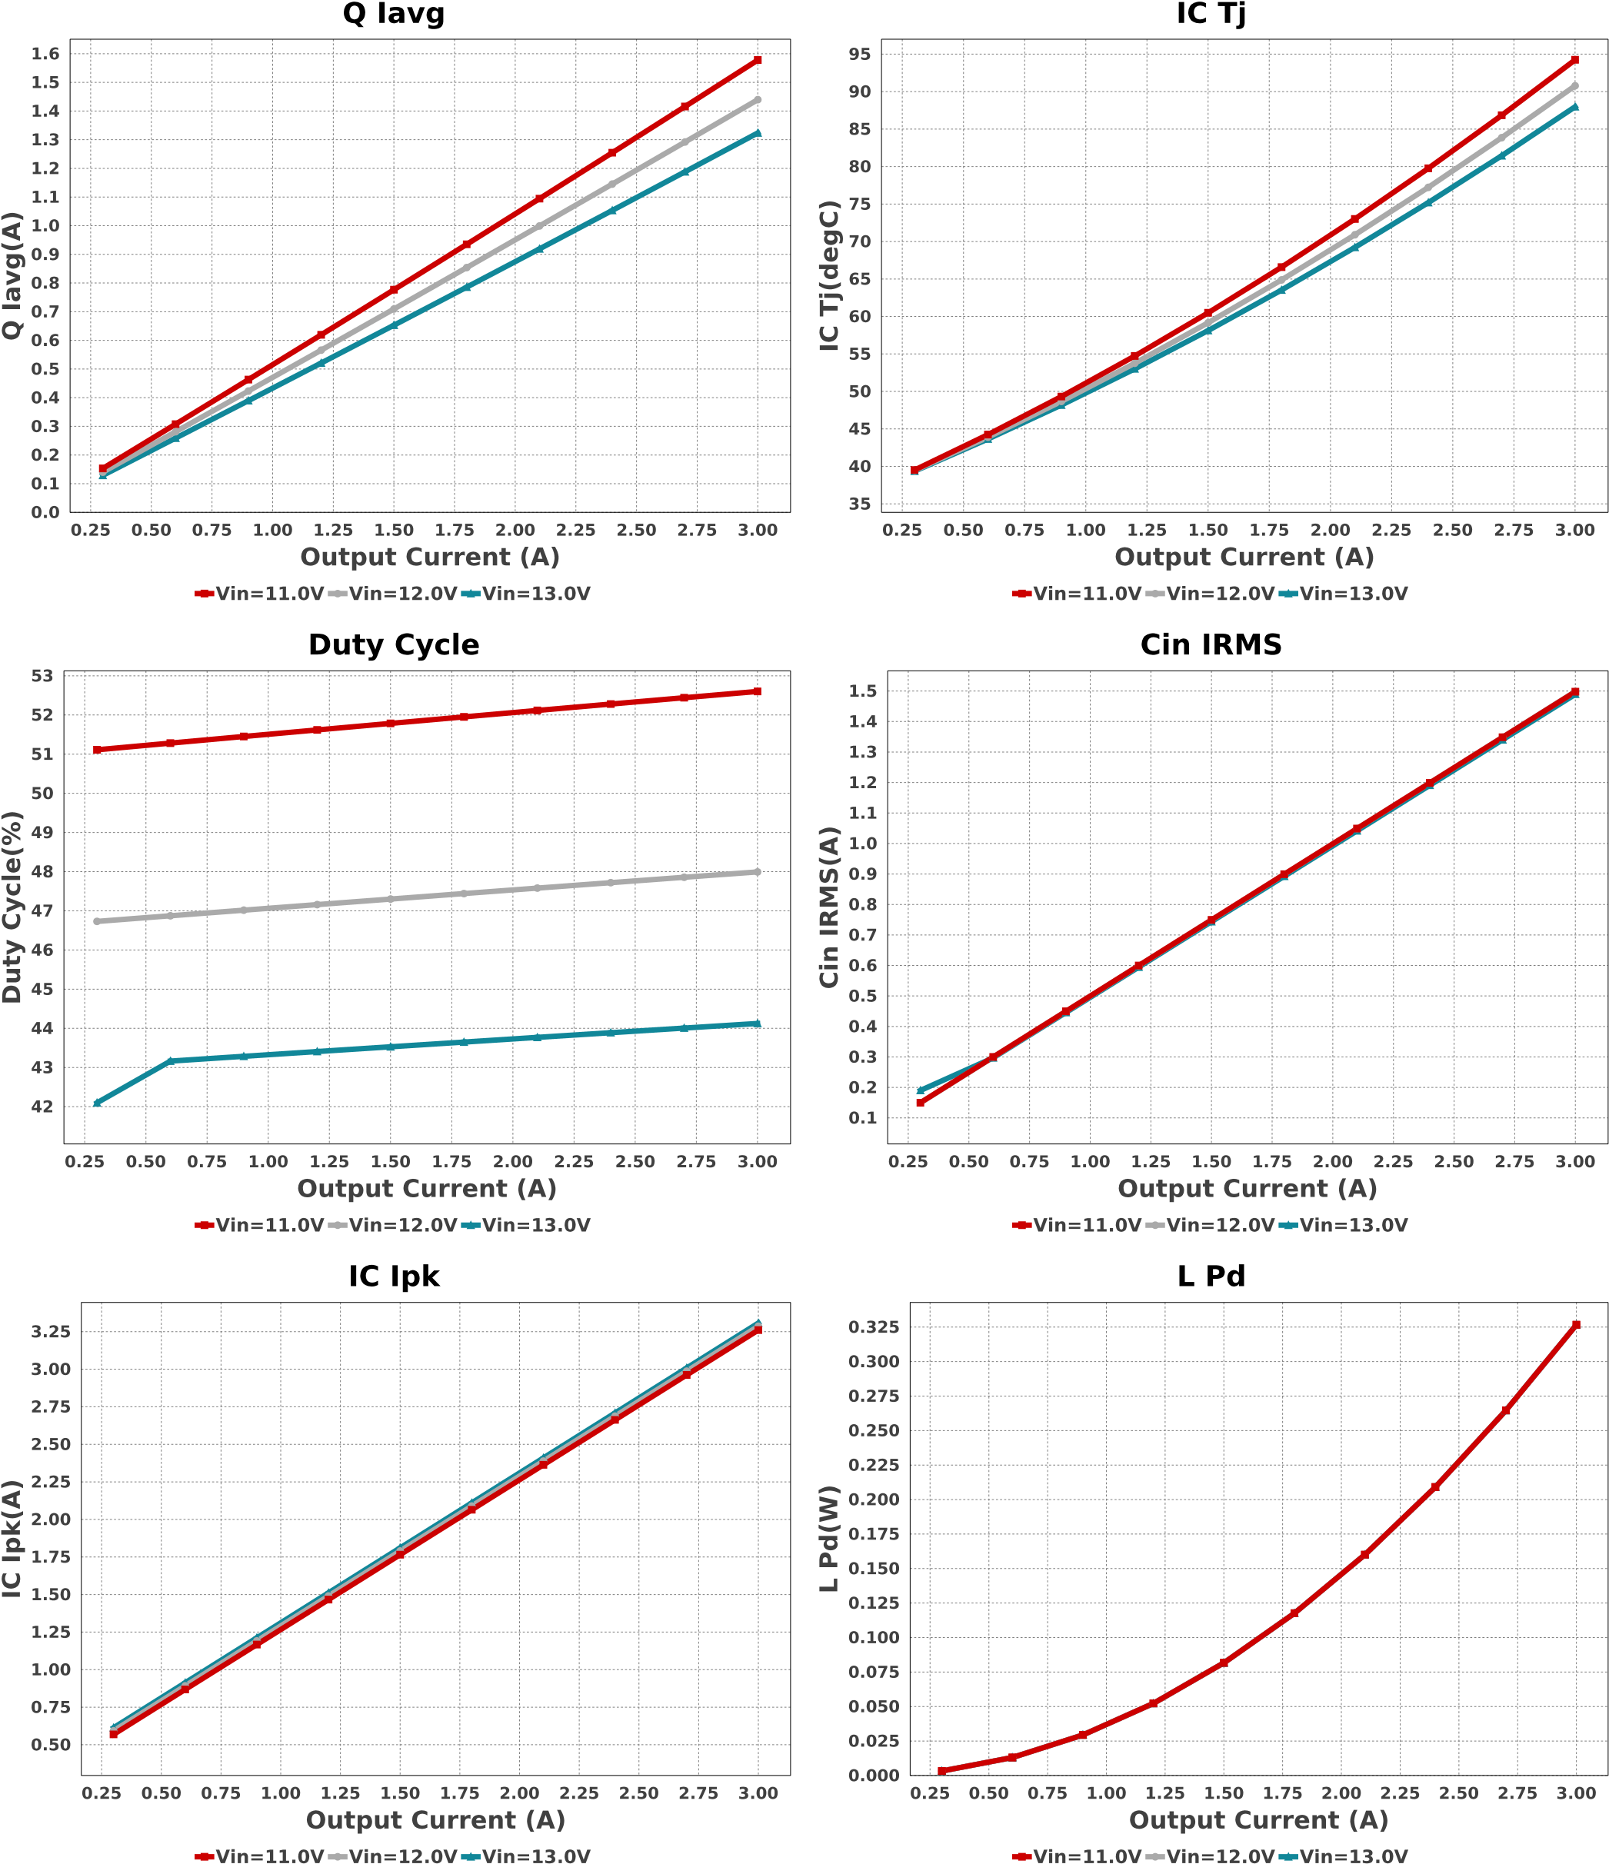

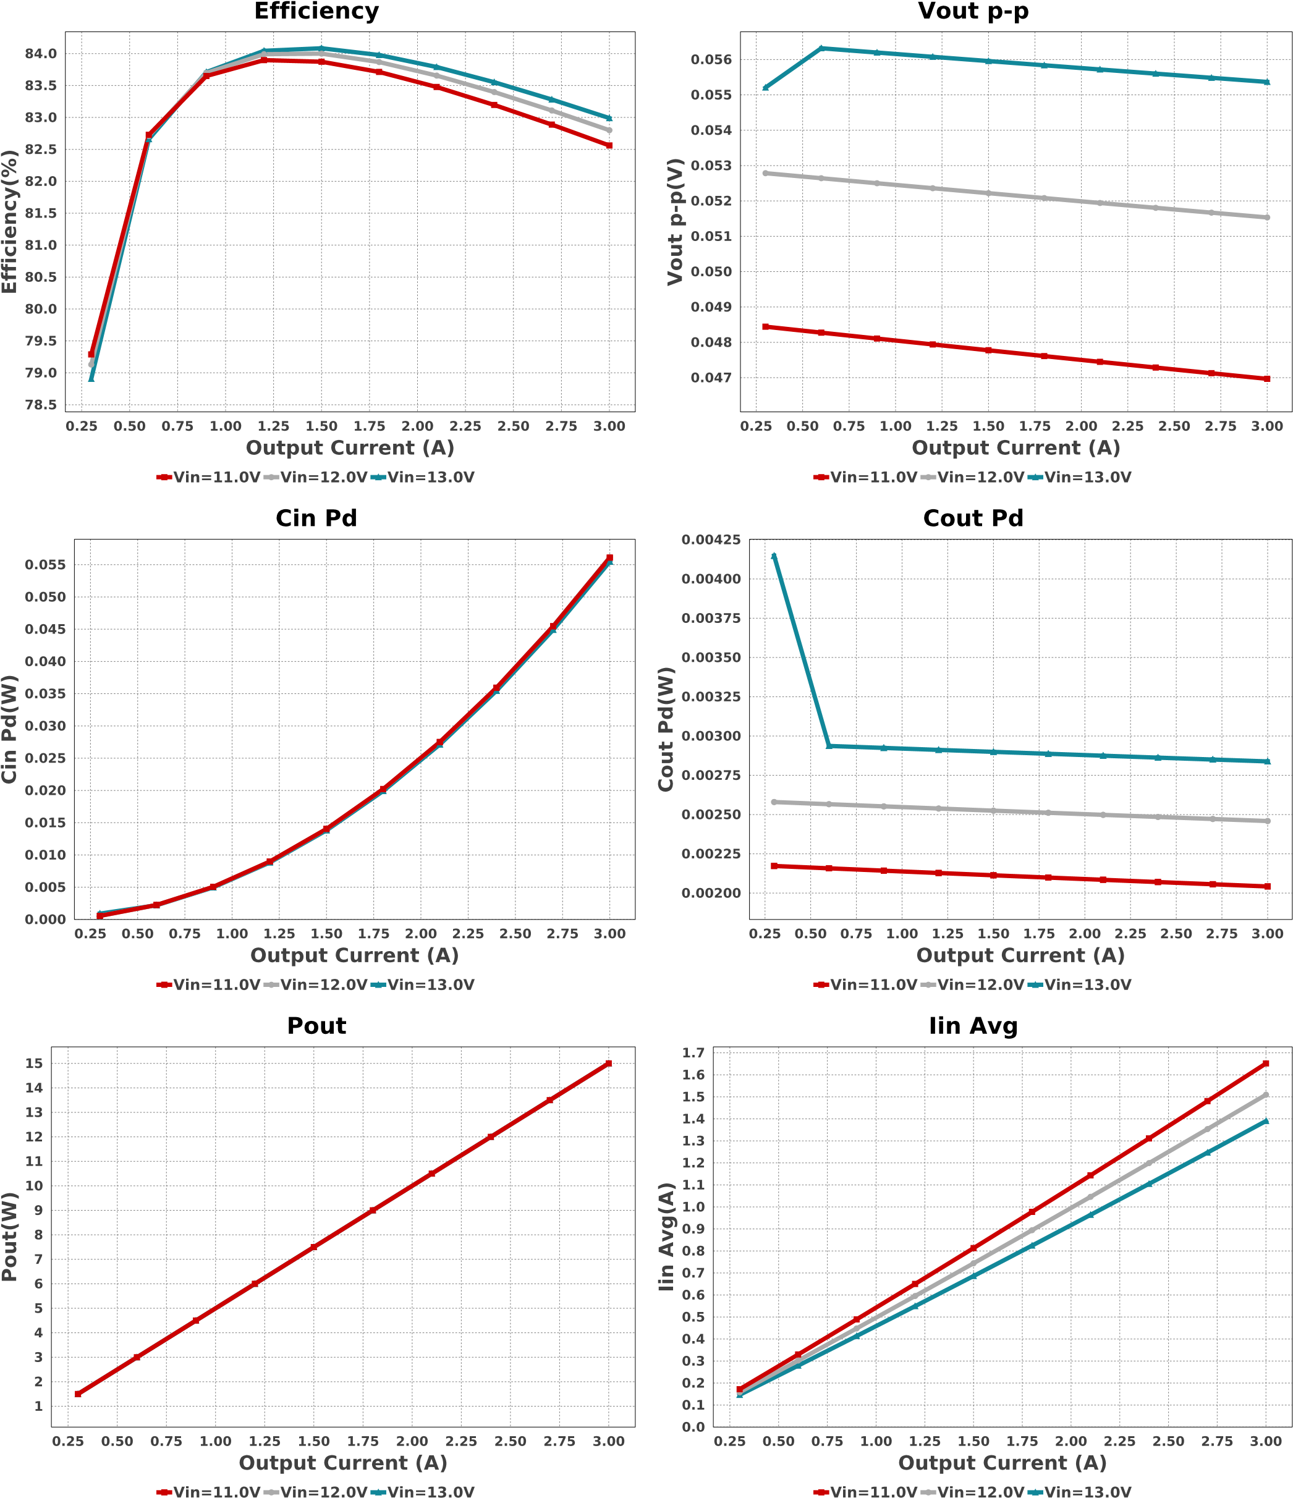

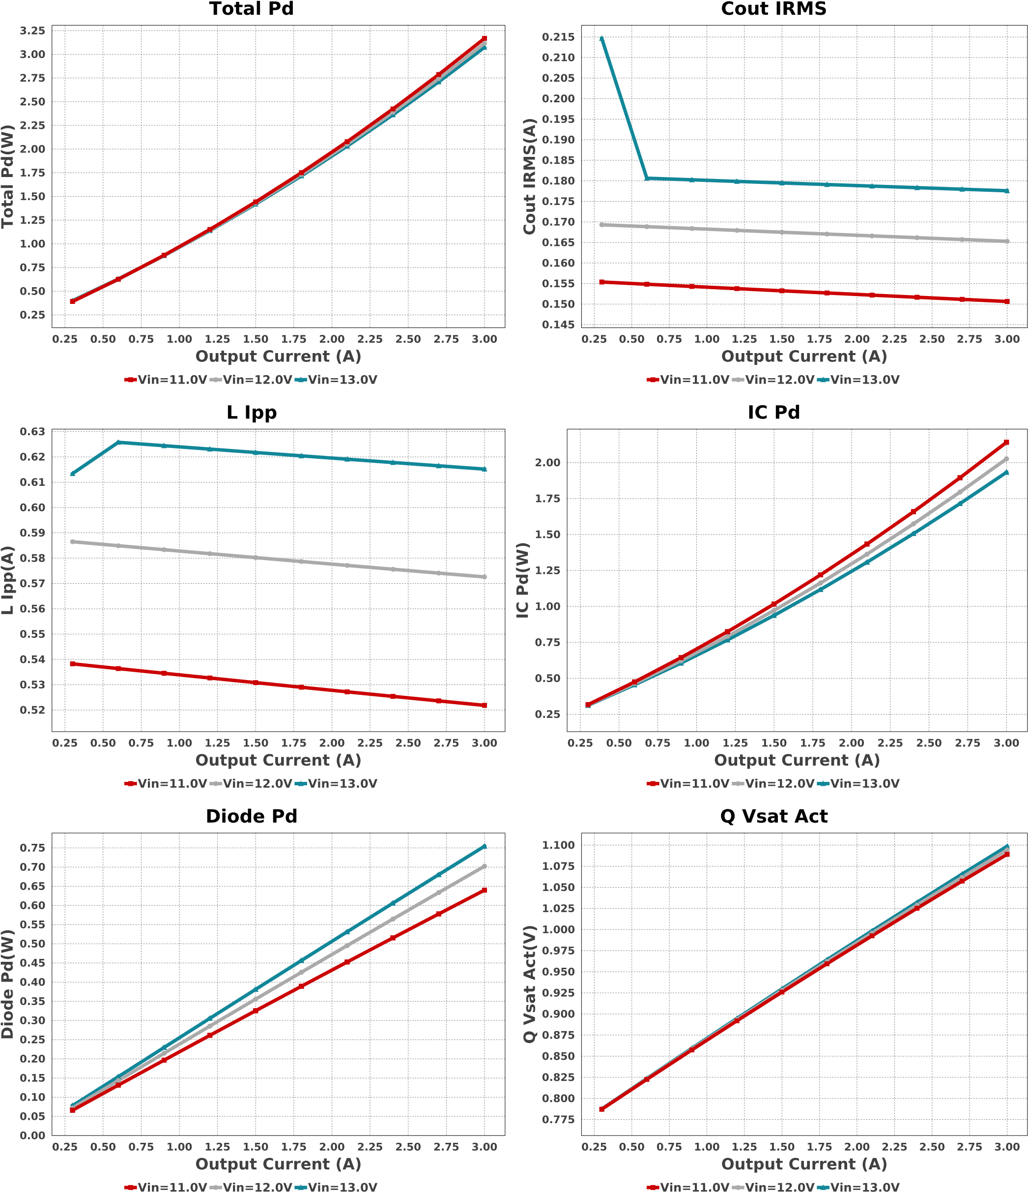

|  |  |  |  |  |
| --- | --- | --- | --- | --- |
| # | Name | Value | Category | Description |
| 1. | Cin IRMS | 1.49 A | Capacitor | Input capacitor RMS ripple current |
| 2. | Cin Pd | 55.473 mW | Capacitor | Input capacitor power dissipation |
| 3. | Cout IRMS | 177.59 mA | Capacitor | Output capacitor RMS ripple current |
| 4. | Cout Pd | 2.838 mW | Capacitor | Output capacitor power dissipation |
| 5. | Diode Pd | 754.31 mW | Diode | Diode power dissipation |
| 6. | IC Ipk | 3.308 A | IC | Peak switch current in IC |
| 7. | IC Pd | 1.933 W | IC | IC power dissipation |
| 8. | IC Tj | 87.98 degC | IC | IC junction temperature |
| 9. | IC Tolerance | 0.0 V | IC | IC Feedback Tolerance |
| 10. | ICThetaJA | 30.0 degC/W | IC | IC junction-to-ambient thermal resistance |
| 11. | Iin Avg | 1.391 A | IC | Average input current |

## Operating Values

|  |  |  |  |  |  |
| --- | --- | --- | --- | --- | --- |
| 12. | L Ipp | 615.19 mA |  | Inductor | Peak-to-peak inductor ripple current |
| 13. | L Pd | 326.7 mW |  | Inductor | Inductor power dissipation |
| 14. | Q Iavg | 1.324 A |  | Mosfet | Q Iavg |
| 15. | Cin Pd | 55.473 mW |  | Power | Input capacitor power dissipation |
| 16. | Cout Pd | 2.838 mW |  | Power | Output capacitor power dissipation |
| 17. | Diode Pd | 754.31 mW |  | Power | Diode power dissipation |
| 18. | IC Pd | 1.933 W |  | Power | IC power dissipation |
| 19. | L Pd | 326.7 mW |  | Power | Inductor power dissipation |
| 20. | Total Pd | 3.082 W |  | Power | Total Power Dissipation |
| 21. | BOM Count | 6 |  | System  Information | Total Design BOM count |
| 22. | Duty Cycle | 44.125 % |  | System  Information | Duty cycle |
| 23. | Efficiency | 82.955 % |  | System  Information | Steady state efficiency |
| 24. | FootPrint | 681.0 mm2 |  | System  Information | Total Foot Print Area of BOM components |
| 25. | Frequency | 150.0 kHz |  | System  Information | Switching frequency |
| 26. | Iout | 3.0 A |  | System  Information | Iout operating point |
| 27. | Mode | CCM |  | System  Information | Conduction Mode |
| 28. | Pout | 15.0 W |  | System  Information | Total output power |
| 29. | Total BOM | $4.3 |  | System  Information | Total BOM Cost |
| 30. | Vin | 13.0 V |  | System  Information | Vin operating point |
| 31. | Vout p-p | 55.367 mV |  | System  Information | Peak-to-peak output ripple voltage |
| 32. | Q Vsat Act | 1.099 V |  | Transistor | Q Vsat |
| Design Inputs | |
| Name | |  | Value |  | Description |
| Iout | |  | 3.0 |  | Maximum Output Current |
| VinMax | |  | 13.0 |  | Maximum input voltage |
| VinMin | |  | 11.0 |  | Minimum input voltage |
| Vout | |  | 5.0 |  | Output Voltage |
| base_pn | |  | LM2596 | | Base Product Number |
| source | |  | DC | | Input Source Type |
| Ta | |  | 30.0 | | Ambient temperature |

# Name Value Category Description

**®**

# WEBENCH Assembly

## Component Testing

Some published data on components in datasheets such as Capacitor ESR and Inductor DC resistance is based on conservative values that will guarantee that the components always exceed the specification. For design purposes it is usually better to work with typical values. Since this data is not always available it is a good practice to measure the Capacitance and ESR values of Cin and Cout, and the inductance and DC resistance of L1 before assembly of the board. Any large discrepancies in values should be electrically simulated in WEBENCH to check for instabilities and thermally simulated in WebTHERM to make sure critical temperatures are not exceeded.

## Soldering Component to Board

If board assembly is done in house it is best to tack down one terminal of a component on the board then solder the other terminal. For surface mount parts with large tabs, such as the DPAK, the tab on the back of the package should be pre-tinned with solder, then tacked into place by one of the pins. To solder the tab town to the board place the iron down on the board while resting against the tab, heating both surfaces simultaneously. Apply light pressure to the top of the plastic case until the solder flows around the part and the part is flush with the PCB. If the solder is not flowing around the board you may need a higher wattage iron (generally 25W to 30W is enough).

## Initial Startup of Circuit

It is best to initially power up the board by setting the input supply voltage to the lowest operating input voltage 11.0V and set the input supply's current limit to zero. With the input supply off connect up the input supply to Vin and GND. Connect a digital volt meter and a load if needed to set the minimum Iout of the design from Vout and GND. Turn on the input supply and slowly turn up the current limit on the input supply. If the voltage starts to rise on the input supply continue increasing the input supply current limit while watching the output voltage. If the current increases on the input supply, but the voltage remains near zero, then there may be a short or a component misplaced on the board. Power down the board and visually inspect for solder bridges and recheck the diode and capacitor polarities. Once the power supply circuit is operational then more extensive testing may include full load testing, transient load and line tests to compare with simulation results.

## Load Testing

The setup is the same as the initial startup, except that an additional digital voltmeter is connected between Vin and GND, a load is connected between Vout and GND and a current meter is connected in series between Vout and the load. The load must be able to handle at least rated output power + 50% ( 7.5 watts for this design). Ideally the load is supplied in the form of a variable load test unit. It can also be done in the form of suitably large power resistors. When using an oscilloscope to measure waveforms on the prototype board, the ground leads of the oscilloscope probes should be as short as possible and the area of the loop formed by the ground lead should be kept to a minimum. This will help reduce ground lead inductance and eliminate EMI noise that is not actually present in the circuit.

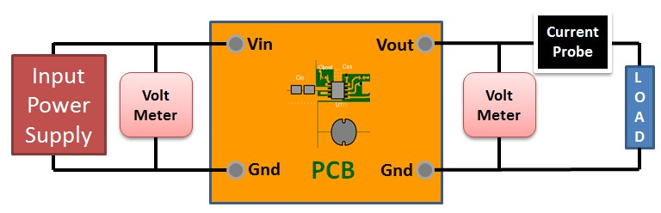

## Design Assistance

1. Master key : 29F0C5E535570A6F9FC1D70942BDB839[v1]
2. [**LM2596** Product Folder : http://www.ti.com/product/LM2596 : contains the data sheet and other resources.](http://www.ti.com/product/LM2596)

|  |
| --- |
| Important Notice and Disclaimer  TI provides technical and reliability data (including datasheets), design resources (including reference designs), application or other design advice, web tools, safety information, and other resources AS IS and with all faults, and disclaims all warranties. These resources are intended for skilled developers designing with TI products. You are solely responsible for (1) selecting the appropriate TI products for your application, (2) designing, validating and testing your application, and (3) ensuring your application meets applicable standards, and any other safety, security, or other requirements.  These resources are subject to change without notice. TI grants you permission to use these resources only for development of an application that uses the TI products described in the resource. Other reproduction and display of these resources is prohibited. No license is granted to any other TI intellectual property right or to any third party intellectual property right. TI disclaims responsibility for, and you will fully indemnify TI and its representatives against, any claims, damages, costs, losses, and liabilities arising out of your use of these resources.  Providing these resources does not expand or otherwise alter TI's applicable Terms of Sale or other applicable terms available either on ti.com or provided in conjunction with TI products. |